A201 Exercise—Math Function Exercise

AUTHORIZED RESOURCES: your instructor, your course notes, course materials and other cadets (but do not copy any of another cadet’s work)

Background:

We have discussed some of Matlab’s math functions and operations. In this exercise you will write two short m-files (4 lines of code or less):
- mag.m
- vecangle.m

mag.m
mag.m will determine magnitude of an input vector. You will use this function extensively over your tenure as an engineering major.

vecangle.m
vecangle.m takes two input vectors and determines the angle between the two vectors using the following relationship:
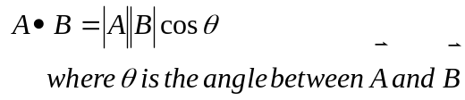

Tasks:
- Write an m-file function, called mag.m that will:
- Find the magnitude of an input vector
- mag.m details:
  - Inputs:
    - vector
  - Outputs:
    - Magnitude of the vector
- Write an m-file function called vecangle.m that will:
- Find the angle between two input vectors
- vecangle.m details:
  - Inputs:
    - Vector 1
    - Vector 2
  - Outputs:
    - The smaller (less than pi radians) angle between the two vectors

Note: You may fulfill these requirements by having the instructor verify your work by any of the following means:
- Signoff by viewing during class assigned -or-
- Bring hard copies to class for signoff

- Documented Code for Both Functions

- Test Case Results for Both Functions

- Hand Calculations for Test Cases

